WORKSHEET
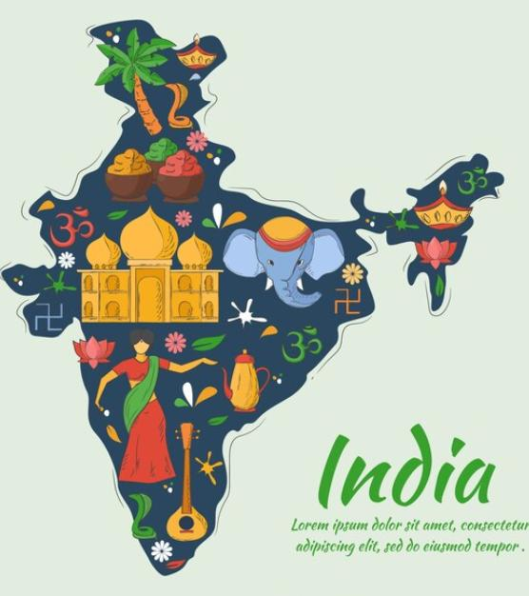
- India with its 28 states and ________ Union Territories is incredible because of its diverse culture and rich heritage.
  - How many Union Territories are there in India?
  - Locate the Union Territories along with their capitals in the Indian Political Map

- Answer the following –
  - The Changpas graze their goats at higher altitudes. Why?
  - The Changpas led a nomadic life moving from one place to another with their livestock. What benefits do they get from their livestock ?
  - Mention 2 factors on which the housing structure of a place depends.

